**HA 8.1: Figure 8.31 shows the ACFs for 36 random numbers, 360 random numbers, and 1,000 random numbers.**

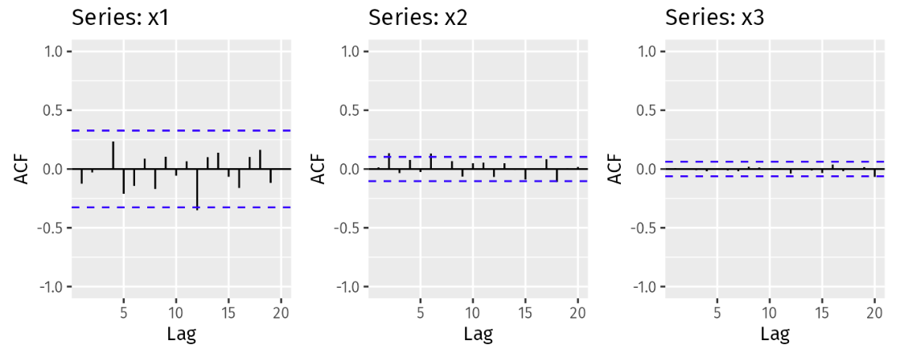

**A. Explain the differences among these figures. Do they all indicate that the data are white noise?**

Yes, all of the above figures indicate that the data are white noise. There is no autocorrelation: the ACFs all fall within +/- $2/√T$, indicated by the dashed blue lines on each chart, so there is no significant relationship between lagged values in the time series.

**B. Why are the critical values at different distances from the mean of zero? Why are the autocorrelations different in each figure when they each refer to white noise?**

The critical values, indicated by the dashed blue lines, represent +/- $2/√T$ where T is the length of the time series. As T increases from 36 to 360 to 1,000, the $\sqrt{T}$ is 6, ~18.97, and ~31.62 respectively.

This has the effect of increasing the denominator and therefore decreasing the value of $2/√T$, narrowing the critical values as seen above. As long as the ACF values fall between the critical values, the data are white noise in all of these examples regardless of the differences in the absolute value of the critical values.

**Code for reference: n/a**